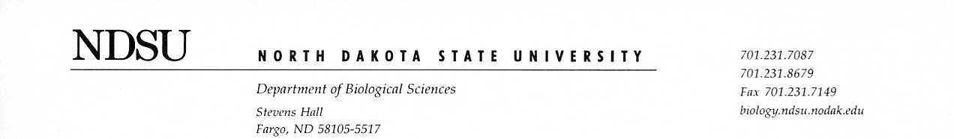
04/09/2021

Dear Editor,

We are grateful for your consideration of our manuscript entitled, “The timing of snowmelt and amount of winter precipitation have limited influence on flowering phenology in a tallgrass prairie.”
In this original work we build a structural equation model to investigate the relationships between winter precipitation, temperature, and flowering phenology using a long-term historical data set. Given the predicted increase in temperature and precipitation in the upper Midwest of the United States, we believe examining the potential consequences to prairie species is crucial. Since the flora of the upper Midwest is similar to that of southern Canada, we believe that this article is relevant and of interest to readers of Botany. Though prior research in alpine and tundra ecosystems have found a strong relationship between winter precipitation and flowering phenology, this is not the case for upper midwestern prairies where temperature drives flowering phenology in most species. We think these results have important implications for the climate change impacts on biota.
The manuscript includes one table and four figures. Potential reviewers for this manuscript include Elizabeth Wolkovich (wolkovic@mail.ubc.ca), Paul Reed (preed@uoregon.edu), and Heather Kharouba (heather.kharouba@uOttawa.ca). We appreciate your consideration of our manuscript.

Sincerely,

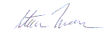

Steve Travers (corresponding author):

Department of Biological Sciences
NDSU Dept. 2715
P.O. Box 6050
Fargo, ND 58108-6050
Steven.travers@ndsu.edu
607-231-9435

